Design Document for Notification
Description:

This document proposes to create notifications for grant.

Design:

The screenshot design of notification list is given below.

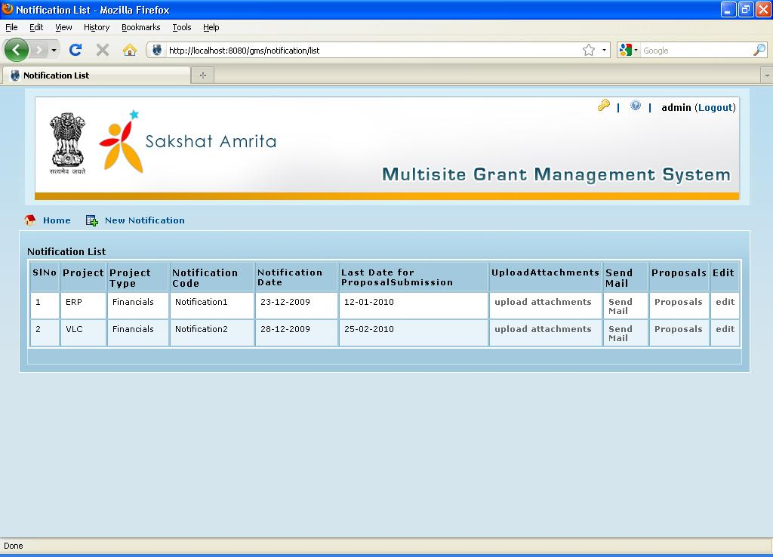

- The Notification list consists of fields
  - ‘Project’ for which the notification is created
  - project type
  - notification code
  - notification date
  - last date for proposal submission
  - ‘Upload attachments’ which is a link to the Upload attachments screen from where we can upload the notifications created.
  - ‘Send mail’ which is a link to the Notification E-mails screen from where we can send notification email to the institutions.
  - ‘Proposal’ is a link to the proposal list. Here the user can view proposal for the notification they sent.

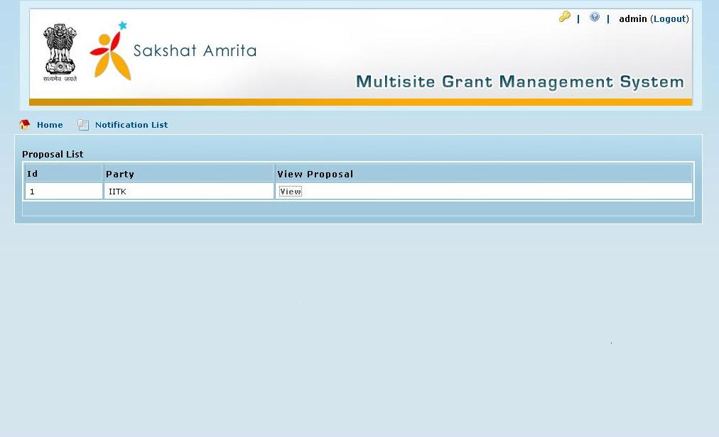

By clicking the view button the user can view the proposal from particular institution.
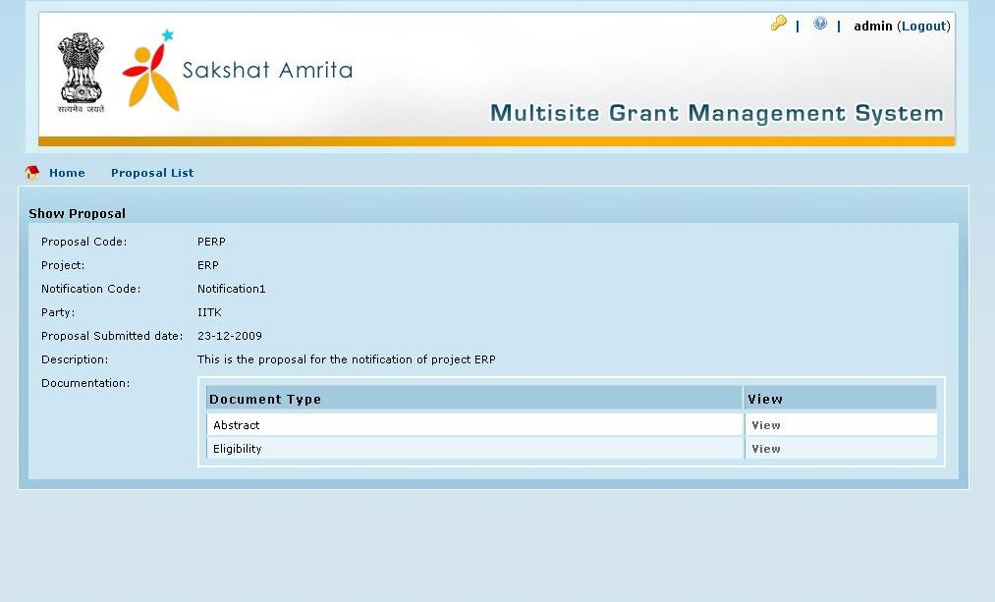

  - Edit button to edit particular notification.
Create notification

Here the user can create notification for particular project. User can enter the details such as the ‘project’ for which the notification is created, ‘Notification Code’, ‘Notification Date’, ‘Last Date for Proposal Submission’ and the ‘description’. Notification will be created when the user clicks on the ‘create’ button.

The screenshot design of notification create screen is given below.

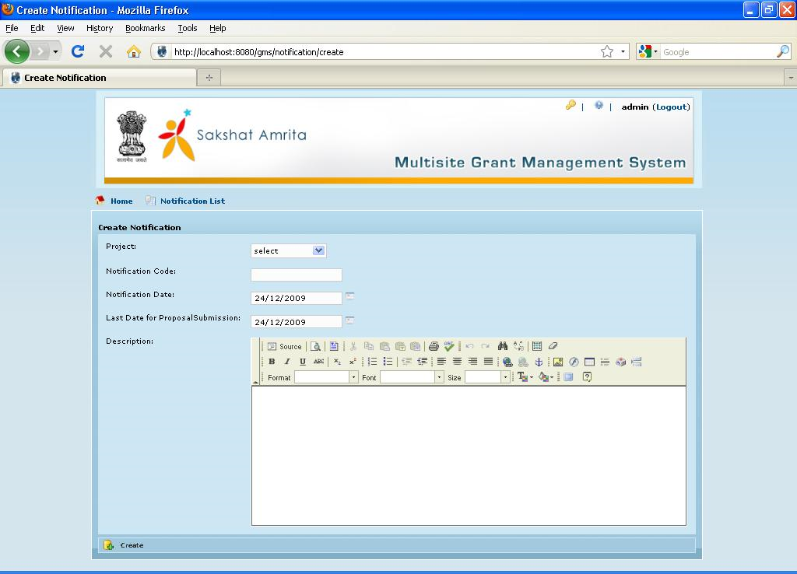

Edit Notification:

- EDIT button is provided in each row of the notification list.
- When we click the edit button will be redirected to another screen where the details of the respective notification will be loaded and a UPDATE and DELETE button is made enabled there.
- Once the details are loaded user can change the values and update by using UPDATE button.
- When we click the UPDATE button the system will update the respective contents in notification list
- The user can delete the respective contents by clicking the delete button

Upload Notification Attachment

- Here there is an option for the user to upload notification attachments. The user should select the notification attachment type which is displayed in the list.
- Uploaded documents will be displayed in the list below. There is a delete button to delete the uploaded document.

The screenshot design of Upload attachments screen is given below.

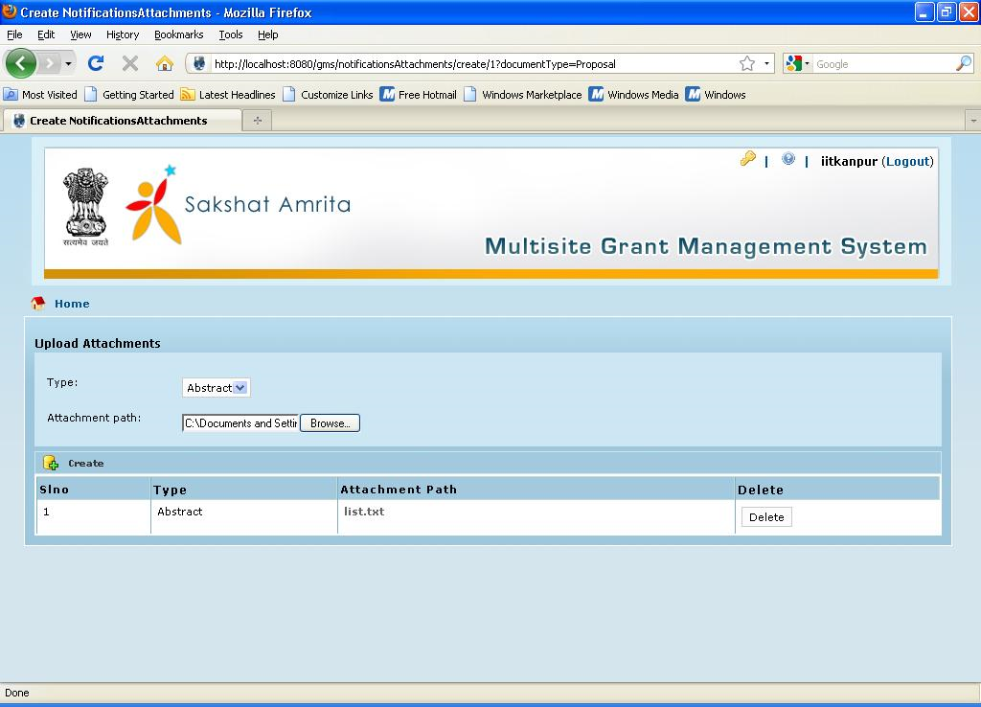

Notification E-mail:

Here the user can send notification email to the institutions. There is an option for the user to type the message and send it to multiple institutions. The screenshot design of Notification e-mail screen is given below.

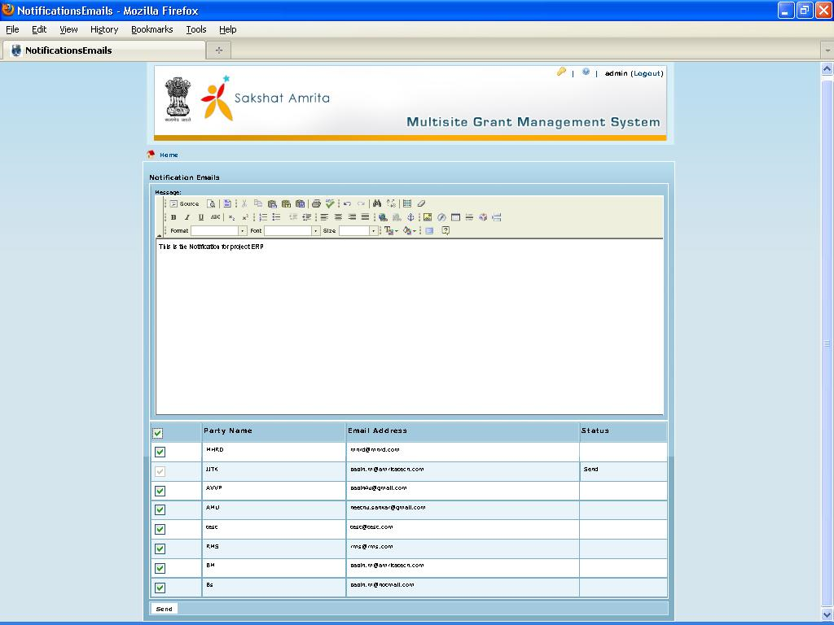

Create Proposal

During the institution login the notification list will be listed as shown below.

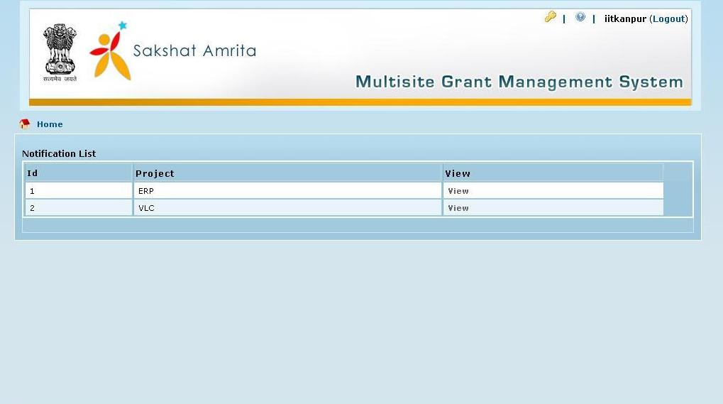

When user clicks on the view button the notification details will be shown.

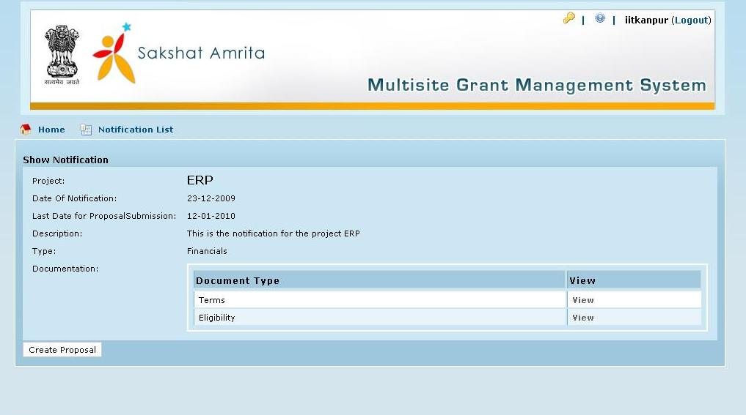

By clicking the create proposal button the user can create proposal for particular notification. User can enter proposal code, submitted date and description.

The screenshot design of create proposal screen is given below.

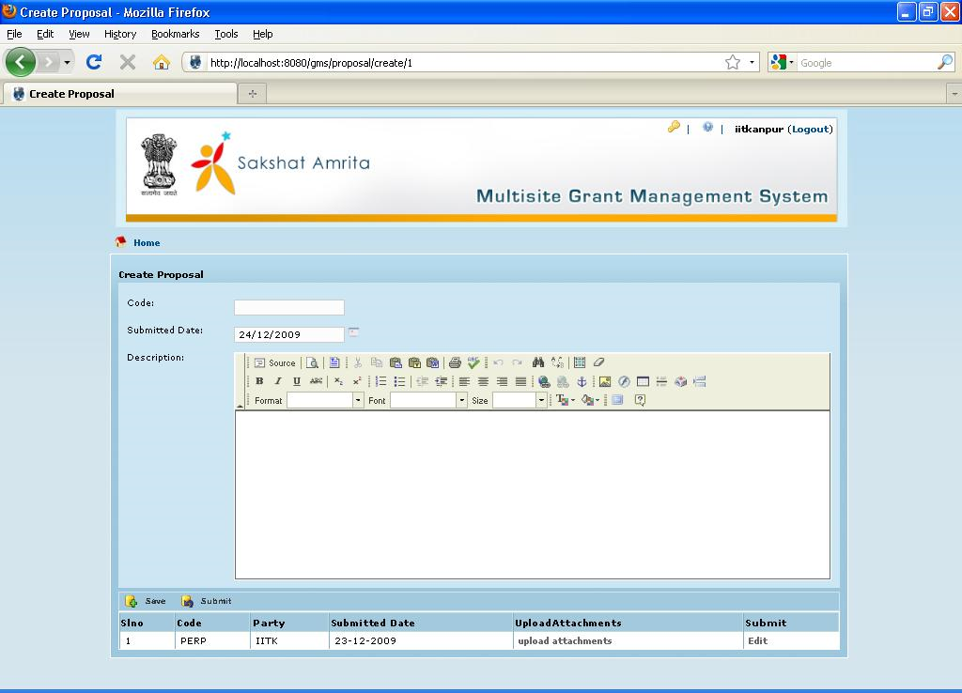

- Here there is an option for the user to save the proposal as draft and submit the same whenever he wants. The saved document will be displayed in the list.
- The user can upload the proposal document by clicking the upload attachments button. The user should select the proposal attachment type which is displayed in the list.
- Uploaded documents will be displayed in the list below. There is a delete button to delete the uploaded document.

The screenshot design of Upload attachments screen is given below.

